CST2560

Project Management & Professional Practice

Group Project

Smart Home Consulting

2022/23

Name: Abdullahi Mohamed Student ID:M00810926
Name: Ali Hassan Student ID: M00853001
Name: Alessio Stefano Dita Student ID:M00809761
Name: Shoyful Islam Student ID:M00811809

CAMPUS: HENDON

Contents Page

Introduction, Project Brief, Consideration of Stakeholders ……………………… page
Brainstorming & Consideration of possible platforms …………………………………page
PID………………………………………………………………………………………………………………. page
Gantt chart………………………………………………………………………………………………………page
Critical Path Analysis…………………………………………………………………………………………. page
WBS ………………………………………………………………………………………………………………………page
4-Fields map……………………………………………………………………………………………………………. page
Design of Smart Homes for all the estate with rationale………………………………………………page
Costing of the technology (do not include installation costs) ……………………………………… page
An outline of possible additional desirable features that might be available at additional cost to the purchasers of the homes……………………………………………………………………………………………. page
Review & Conclusion……………………………………………………………………………………………………. page

Introduction
The project objective is to provide advice on smart technologies which can be used in homes and evaluate the requirements of the technology for the different homes. There will be three different home types which will have different requirements however we will provide a list of technology which will be compatible for all the homes. As there will be different requirements for each of the homes will have an additional list which will have smart technology, we recommend but may not be suitable for all the homes but for a specific home. We will explain in detail about its suitability for each type of home. The three different types of homes a 6 * 4-bedroom family home, sheltered accommodation for fourteen elderly people (they may have disabilities) which will require to have a warden in place and an 8 * 2-bedroom affordable starter homes.
Smart home technology refers to a convenient home setup where appliances and devices can be automatically controlled remotely from anywhere with an internet connection using a mobile or other networked device (Adam Hayes, 2022). There are many benefits of smart homes, and this is why we have seen an increase in demand for the technology and constant evolution. Most homes in developed countries are subconsciously using smart homes technology for example smart TVs are a great example of this as in 2014 just 11% had smart TVs in the UK compared to 2022 where 67% of households had a smart TV. This graph shows the considerable increase in demand over the last few years. (Statista, 2023)
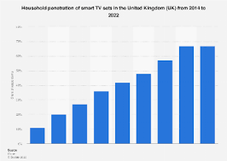

Smart technology has developed to become a solution for many days to day activities for example it helps in healthcare as it makes the activities that one must carry easier or even achievable which may not have been possible beforehand. This is vitally important for this project because in the sheltered home there may be residents with disabilities also in the two other types of homes this could also be the case, but it seems like it would be less likely from the information we have been provided. We know in recent years especially due to Covid-19 pandemic the healthcare has been stretched to the limits which shows that there are limited resources available. This is where smart home technology can come in and reduce the workload as people will be able to monitor their health from their own residence and this will lead to a healthier lifestyle. Another aspect of smart technology in terms of healthcare it will help with mental and physical health and when we consider the increase in mental health cases this shows the importance of smart home technologies. The healthcare professional will also be able to act quickly if they notice anything irregular in the data they are receiving. Finally, you should always consider each resident as a different case as some will seamlessly adapt to using smart home technology for healthcare whereas some may struggle as it might cause paranoia or delusion for example, and this can be common when using certain technologies. [1]
Many homes have used conventional security systems to keep themselves and the home safe and this shows the importance of security in a home. Smart home technology is even more secure than the conventional security as it is able to alert the owners if there are any problems which allows them to be able to investigate it before it leads to a greater problem. You are also able to use artificial intelligence with smart home technologies which will be able to understand the homeowner and keep hold of valuable information and inform emergency services where applicable. There are many different aspects of how smart homes technology can be implemented in a home to make it secure and the main categories and the most widely used are fire protection systems, access control and as we have briefly discussed before artificial intelligence in terms of protecting the homeowner. We do currently have the conventional fire alarms however they are nowhere near able to be as secure as the smart home technology and the potential is far more grater as artificial intelligence can be incorporated into it to pinpoint specific areas of the fire. When we talk about access control in terms of smart technology it will detect whether the person is a resident of the home, a cleared visitor or an intruder and based of the information it has gathered it will act accordingly. Also, artificial intelligence in homes allows the resident to have better health care as if it detects irregularities in your activities it can contact friends or family to allow them to check up on you. (Robles, R. and Kim, T.-H., 2010)
There are many other benefits to residents of a home that use smart home technology can have other than healthcare and security. For example, to briefly name a few categories you could use it for fitness, aesthetics of the home and each individual will be able to customize it to their preferences, it will also help keep the costs down in the long term and cooking as there is plenty of smart home technology that can be incorporated into the kitchen. Even though we have stated that it will keep down cost it is important to be aware that the initial costs are high but will discuss this in more detail later so that you are able to make the best possible decisions on what smart home technology you wish to be implemented within your project. (Robles, R. and Kim, T.-H., 2010)
As we see an increase in the use of the internet it has become vital that we have the correct maintenance and network security in place because the information and tools required to penetrate networks are widely available. There are tools available for finding weaknesses which can be used in a positive manner as if you are aware of the weaknesses then you are able to better protect the network by taking the adequate steps. The reason as to why this is an important aspect of smart home technologies because when you will have sensitive and confidential information which you will not want to be stolen, destructed, corrupted or even have information introduced which will create damage difficult to repair. (Robles, R. and Kim, T.-H., 2010)
We will need to be aware of the possible stakeholders and how their importance may influence our decision making. We have used a power interest matrix to illustrate this:

Local Council: The local council fits in the High Power – High Interest stakeholder category. This is because the council will have high power over the project as ultimately, they will decide if the project can go ahead or not based on different regulations set in place about health & safety, energy consumption etc. They also have high interest in the project because it will directly impact the local community. Construction of modern, smart homes in the area could promote increased development in the local area as well as an increase in the influx of inhabitants. Therefore, we need to work closely with the council in order to ensure all regulations are met and everything is legally in place for the smart homes to operate.
Occupants: The occupants of the smart homes will fall in the Low Power – High Interest category. This is because they will be the ones benefiting from the smart homes as they will live inside them. Although they have high interest, they don’t have much power in the project itself. They don’t have much say in the decision making because all decisions about the smart home technology being implemented within the homes will be made by the Project Team Members.
Care Home Owners: These are one of the most important stakeholders therefore they fit in the High Power – High Interest category. Since the care home will be the biggest building of the project, we need to ensure that everything is perfect and follows the client’s requirements (Care Home Owner). We will have to be in constant communication with them as they will be the ones we need to convince about implementing our recommended smart home devices explaining why it would help the occupants and the staff members of the care homes as well as how in the long run they would be a good investment financially as well as for the quality of life of the care home residents. This will make it a highly reputable care home which in turn will help the owners increase their profit.
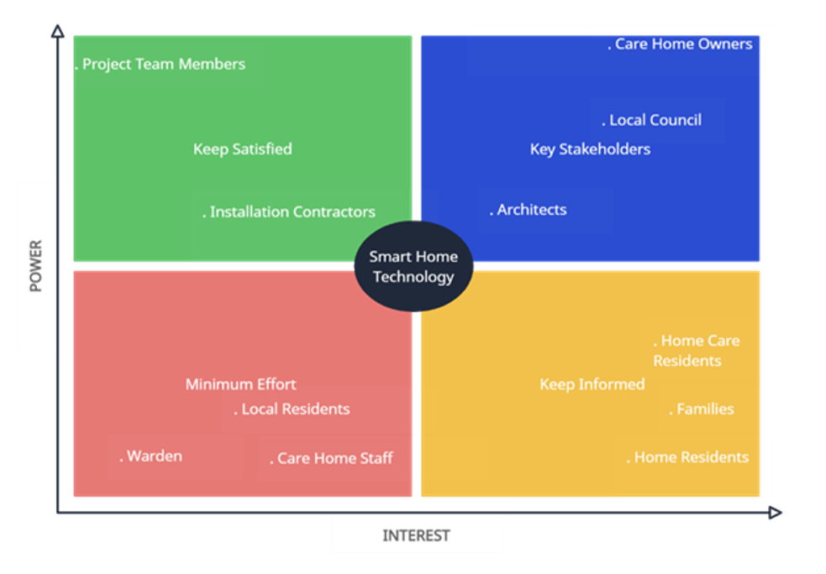
Architects: The architects also fall in the High Power – High Interest category but they are lower than the care home owners on the scale. They will be able to communicate with the local council to make sure all smart home technology that will be implemented is within the regulations. Also, they will be able to advise us on potential risks we should consider in our project.
Brainstorming and consideration possible platforms
Brainstorming
I will be brainstorming ideas for our smart homes project to which I will talk about which potential smart features and systems we will incorporate.
Discuss the smart technologies that will be used in the smart home project:
Internet of things: Network devices such as sensors, software applications and connectivity.
Smart connected device is remote and connect either to an internet or Bluetooth e.g., smart security cameras, smart bulbs, smart kettle, smart tv, smart coffee maker and smart toilets.
The reason smart technology is necessary is because of convenience, ensure sustainability, security, efficiency and save time and money.
RezaID (2023), what is smart technology?, available from Kelly Bowers at https://rezaid.co.uk/smart-technology-and-its-benefits/ ![date accessed 28th February 2023]
Smart home features
Smoke detection alerts will be a necessary in our design if there are any hazardous situation in the home.
Security system will be implemented at our front door through facial recognition, this will help identify from inside the home and only be unlocked by someone inside.
Led lights in the living room for one of our designs because the family home may have kids therefore bright colours can help entertain them.
Light automation will be in use for the elderly home because they have less vision in eyesight.
Consideration Possible platforms
We have been researching designing tools to use in our project the three we narrowed it down to was theme forest, smart trilogy, and we draw max. The one we chose to use is e draw max because of its functionality, it had all the features we would like to implement in our smart home project. In addition, the layout of the smart home design suits our planned design.
Edraw max (2023), all in one diagram available from wonder share at: https://www.edrawsoft.com/ad/edraw-max-soft-t.html ![date accessed 28th February 2023]
Project initiation document: Smart Home
Project Summary
An overall design for smart home type, with costing of all. Sheltered accommodation with a warden for 14 elderly people, 8 by 2 bedroom, and 6 by 4 family bedroom. To also engage and evaluate appropriate technologies that can be incorporated into the designs.
Purpose
Explain in bullet points the key aims of the project?
- Why is the project being undertaken?
- What are the key deliverables?
The project is being undertaken because we need to build smart design homes for elderly people and families. The key deliverables are to incorporate smart features and system to help design a good project.
Project Objective and aim.
The aim of the project is to
Scope and exclusions
The scope is a way to set boundaries and set goals.
- Brainstorm and Consider platforms to design smart homes.
- Design a work breakdown structure, Gantt chart,4 field map and critical path analysis.
- Design smart homes
- Cost of all technology
- Outline additional desirable feature and its cost.
The exclusions that are in this project is that we don’t build the project we are only responsible for the designing phase of the project.
Those above are all the scopes and exclusions that we need to follow to product a good project.
Exclusions is that where not building the home we are designing it.
Product Description
Deliverable ID | Deliverable Title | Deliverable Description
1.1 | Consider platform and brainstorm | Find software for smart home design
1.2 | Design wbs, Gantt chart, 4fields map and critical path | Included all necessary point
1.3 | Design smart home | Include smart features and system
1.4 | Calculate cost of technology | Find cheap prices for technology
1.5 | Outline additional features and cost | Include any added feature

Resource Plan
- Roles are set for each group member.
- 2 meetings per week
- Review each set of design phase.
- Calculate necessary cost.
Assumptions
The first assumption that I will make is that the heating for all home is already instilled. Another thing I will assume is that flooring, and curtains will come with it.
The second assumptions are that the all the cost supplies will be delivered on time for the project.
The last assumption is that the design will be done in the scheduled time.
Monitoring and Evaluation
I will be discussing how the project will be monitored and evaluated.
- We will be taking consistent feedback back from our tutor in your laboratory.
- We will respond with the feedback by improving each aspect of our project e.g., changing details of Gantt chart or changing the times of the critical path.
- We have a timeline for project deadline to which we will be managed to complete and overview.
Initial risk log
Down below is a risk matrix that is displaying the potential risks that can occur in a group. I have also included the potential impact each flaw can have on your project and provide a mitigation(solutions) for each problem we face in our project.
Risk Matrix
It is a tool used to assess any problems that can occur and how to overcome every decision, I will be provide a solution for each. The colour coded are my personal opinions.
Table 1 Risk Matrix
Risk Description | Potential impact on project | Likelihood of occurrence | Difficulty of timely anticipation | Overall threat | Solutions
Poor Communication  (My. UQ, 2022) | high | high | low | high | Clarify anything not understood by peers and allow everyone to voice their opinions.
Dominant team members  (Derby, 2022) | medium | high | low | medium | Split the work between every team member.
Isolation of Group Member  (Learning and Teaching, 2022) | medium | high | medium | medium | Review the roles and responsibility of all team members
Loss of individual Creativity (Library and Services, 2022) | low | high | low | low | Group discussion with explanation

Poor quality design (Simplicable, 2023) | high | low | medium | high | Hire experienced designers who have previously design smart homes
Designs not meeting deadlines (Insureon ,2023) | medium | low | high | low | Weekly meeting to go over timing strategy.
Loss of control in services that authorities (The guardian,2014) | medium | low | medium | medium | Agree with the set requirement to please local council.

References
Team members
my.UQ(2022), Resolving work issues, Available from: university of Queensland at: https://my.uq.edu.au/information-and-services/student-support/study-skills/group-work/resolving-group-work-issue ![date accessed: 20th February2023]
Learning and Teaching(2022), Common group challenges and solutions, available from: Iowa state university at: https://www.celt.iastate.edu/instructional-strategies/effective-teaching-practices/group-work/common-group-work-challenges-and-solutions ![date accessed: 20th February 2023]
Library and Services (2022), Advantages and challenges of group work, available from: Sheridan at:https://sheridancollege.libguides.com/c.php?g=710256&p=5060349![date accessed: 20th February 2023]
University teaching & learning centre (2022), Common problems and solution for group work, available from:GW at:https://ceils.ucla.edu/wp-content/uploads/sites/2/2016/11/3.4a-Common-Problems-and-Solutions-for-Group-Work.pdf ![date accessed: 20th February 2023]
Architecture
Simplicable (2023), What is architecture risk? Available from project management at https://simplicable.com/new/architecture-risk#![date accessed Friday 10TH March 2023]
Insureon (2023), risk management threats for Architects available from staffs at: https://www.insureon.com/blog/top-risk-management-threats-for-architects![date accessed Friday 10th March 2023)
Local Council
The Guardian (2014),risk councils face in projects, available from newspapers at: https://www.theguardian.com/local-government-network/2014/mar/18/[!date accessed Friday 10th March 2023)

End of Project initiation document: Smart Home

Activity List
It is a document that includes all the scheduled activities that are a part of a project, to which when it completed proceeds on to the next one. They all have dependency which means it can only start when that certain activities are finished. (Invensis, 2023)
Invensis(2022),Define Activity List and Examples in a Project, available from Global Learning Services at: https://www.invensislearning.com/blog/define-activity-list-in-a-project/![date accessed 10th March 2023)
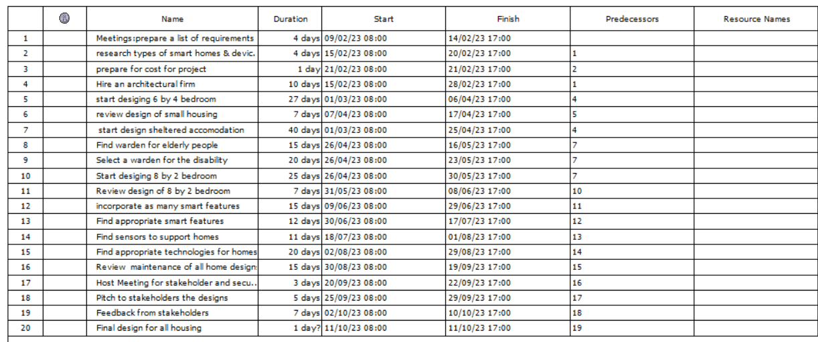
Gantt Chart
It is usually used in project management and it is a common way to show a diagram in a project. It has the timeframe of each from the start date, end date and duration. (Gantt.com,2023)
Gantt.com (2023), What is a Gantt chart, available from Gantt chart software at: https://www.gantt.com/ ![date accessed on March 10th 2023]
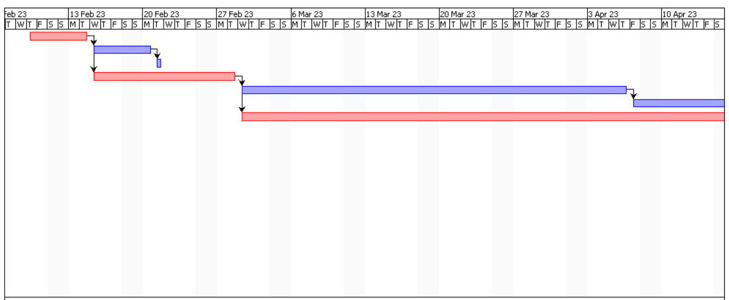
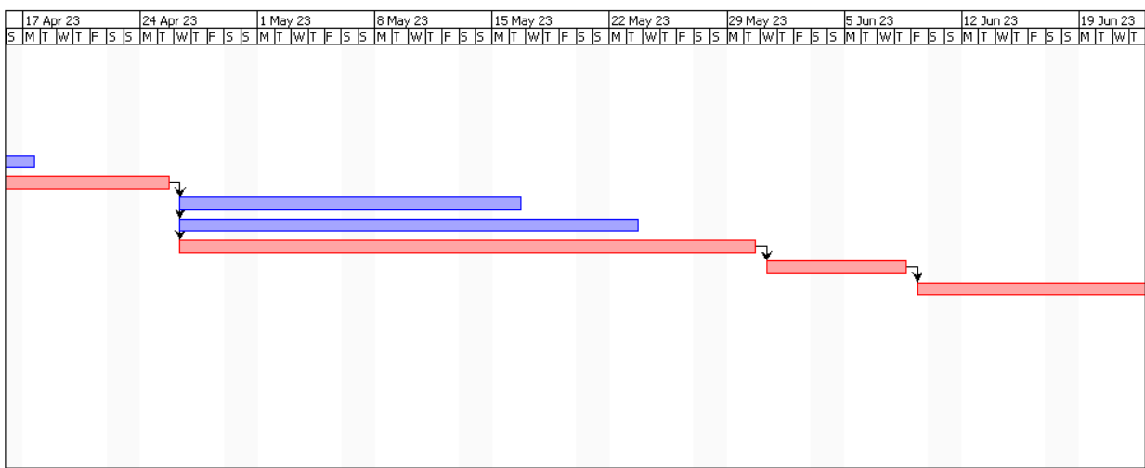
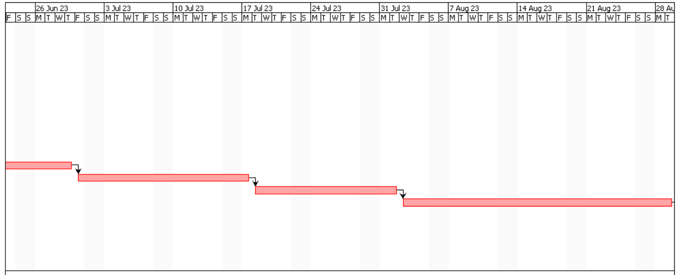
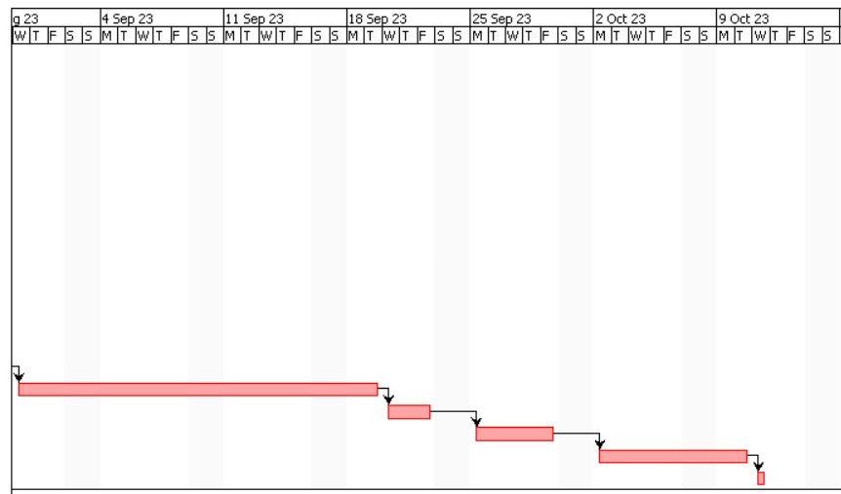

2nd gantt chart
As you have request sir, I have created a 2nd gantt chart as you said you will prefer 10 activities and all in one screenshot if it is okay let me know which I can keep.
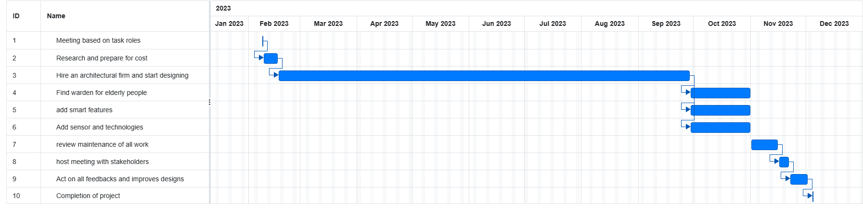
Critical Path
Critical Path – this is where we can see the paths which will not have any flexibility as they will cause a delay in the completion of the project. It is important to be aware of this path because any changes in the time taken it will affect the time duration you will complete the project thus allowing you to evaluate whether this is a feasible and realistic activity for the project. (Project Manager,2023)

Project Manager (2023),12 Effective communication strategies at work available from leadership at: https://www.projectmanager.com/guides/critical-path-method ![date accessed Friday March 10th, 2023]
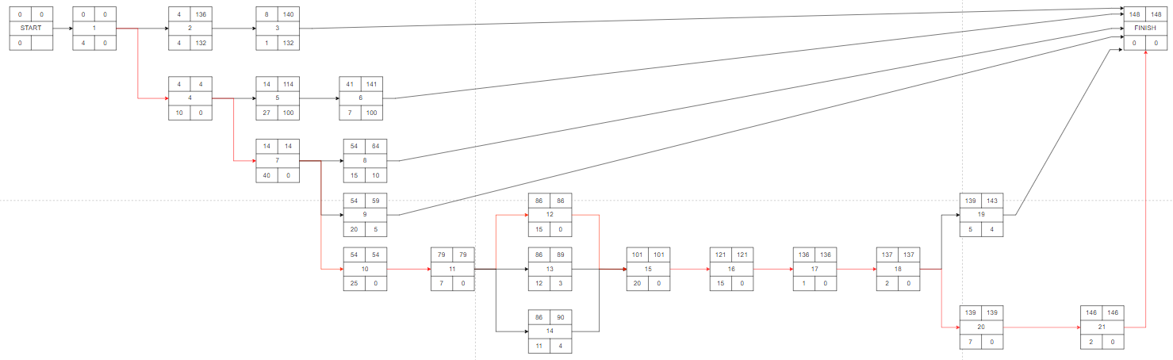

WBS
It is a tool that utilizes efficiency and documents the most important parts of a project. This enables the project manager to a gather a better thought process of how to start. (WBS,2023)
WBS (2023), what is work breakdown structure, available from WBS dictionary at https://www.workbreakdownstructure.com/[!date accessed Friday 10th March 2023]
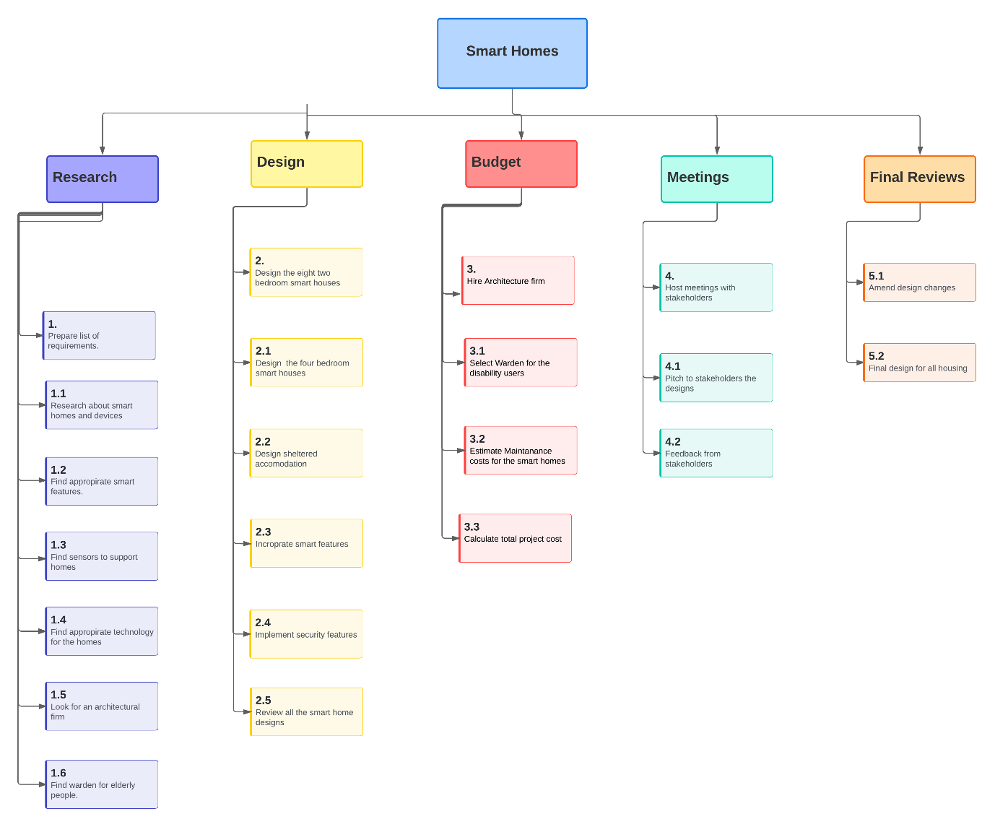

4-Fields Map
It is a graphical tool that is used to plan methods of a project, it is a cross functional process to ensure productivity and roles. (TCGen,2023)
TCGen (2023), Four fields map, available from Jeanne Bradford at: https://www.tcgen.com/blog/optimizing-processes-four-fields-mapping/![date access Friday 10th March 2023]

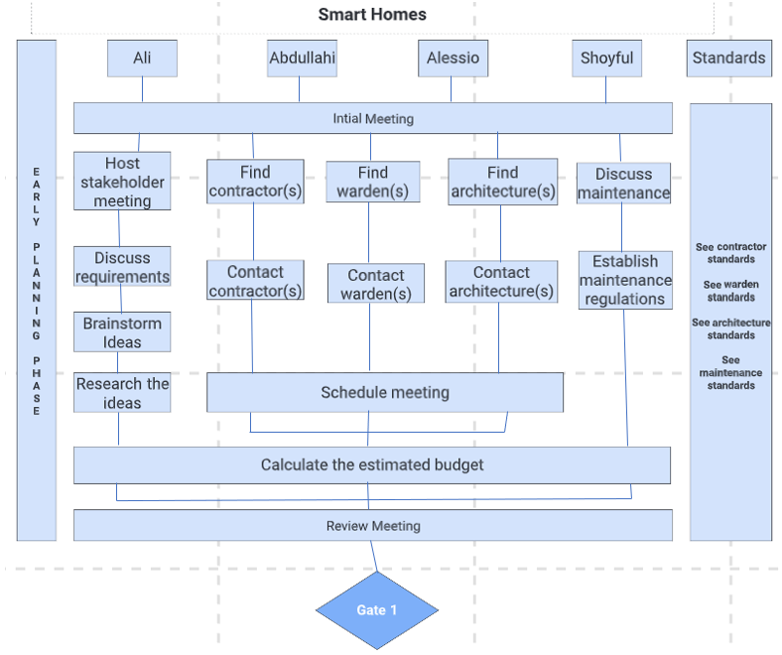

Gate 1 Criteria:
- Is there a contractor available?
- Is there a warden available?
- Is there an architecture available?
- The project requirements have been cleared with the relevant stakeholders.
- Clear plan on how to continue planning.
- Suitable documentation for maintenance upkeep.
- Should have an estimated budget.

Standards:
- The contractor needs to be available for the given timeframe and be up to date with current technology and evidence of previous projects which show this.
- The warden needs to be Criminal Record Bureau (CRB) checked and available to work on the allocated timetable.
- The architecture needs to be able to coordinate design the homes.
- The documentation for the maintenance needs to be approved and signed by everyone involved.
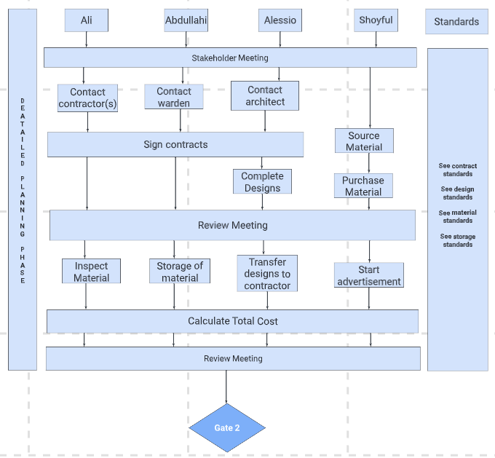
Gate 2 Criteria:
- Has contractor signed the contract?
- Has the warden signed the contract?
- Has the architect signed the contract?
- Design should be finalized and handed over to the contractor.
- All the materials should be purchased.
- Storage should be arranged for materials.
- Planning for advertisement should begin.
Standards:
- All contracts need to be signed and dated by the relevant individuals and everyone should be provided with a copy. This copy should be stored away safely.
- The design should be up to industry standards.
- All the research has been done on the material and therefore the material that arrives should fit what was expected.
- The storage facilities should be able to contain all the materials that have been purchased and the location should be easily accessible in terms of transportation.

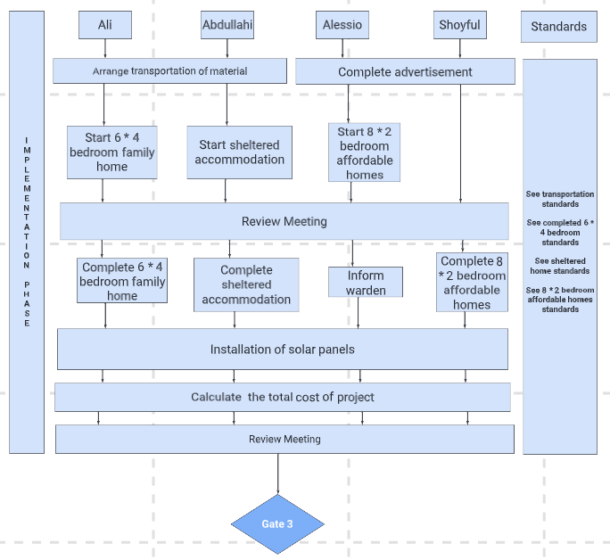
Gate 3 Criteria:
- The 6 * 4-bedroom family home should be completed.
- The sheltered home accommodation should be completed.
- The 8 * 2-bedroom affordable homes should be completed.
- The warden should be updated on the estimated project completion and their start date.
- Solar panels should be installed after completion of the implementation.
- Cost of the project should be calculated.
- Advertisement should be completed by now.

Standards:
- The transportation should be planned with the contractors on time that they require so that there are no delays in the implementation phase of the project.
- All the basic smart features should be implemented for the 6 * 4-bedroom family home as a minimum and any additions if they were chosen.
- All the basic smart features should be implemented for sheltered accommodation as a minimum and any additions if they were chosen.
- All the basic smart features should be implemented for the 8 * 2-bedroom affordable home as a minimum and any additions if they were chosen.

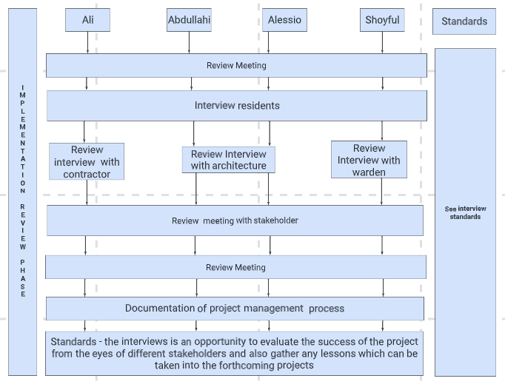

8x2 bedroom
This Is our final design for the 8 by 2 bedroom which is an affordable starter home.
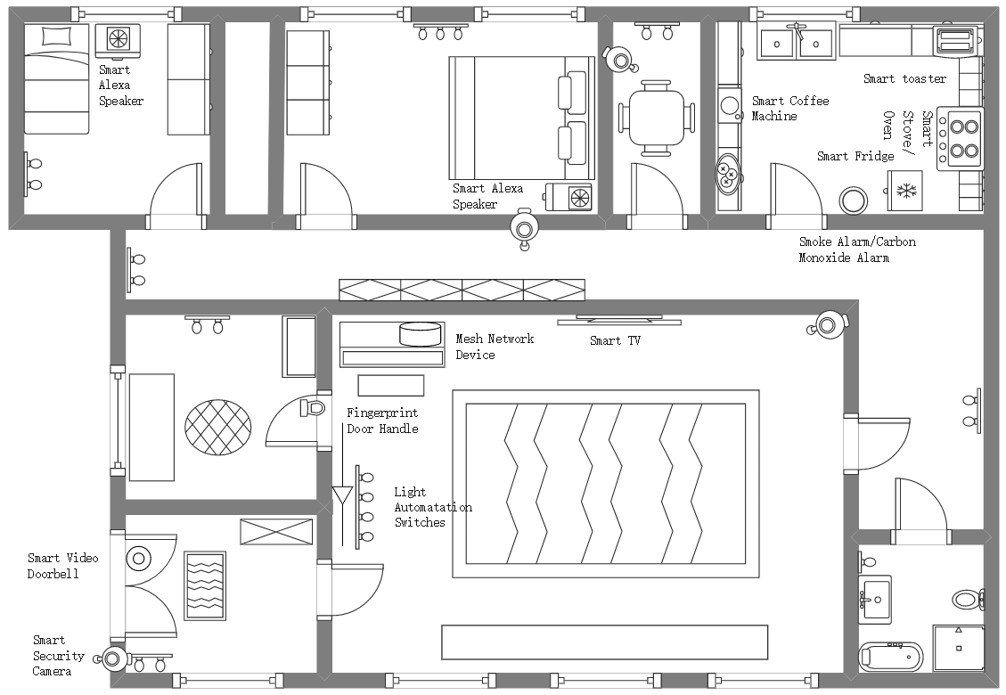
Edraw max (2023), all in one diagram available from wonder share at: https://www.edrawsoft.com/ad/edraw-max-soft-t.html ![date accessed 28th February 2023]

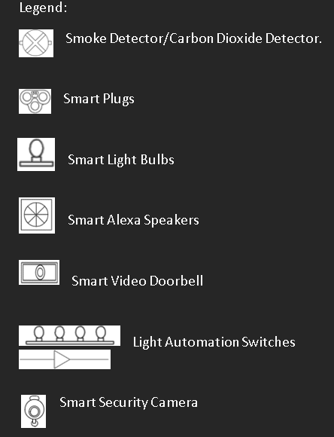
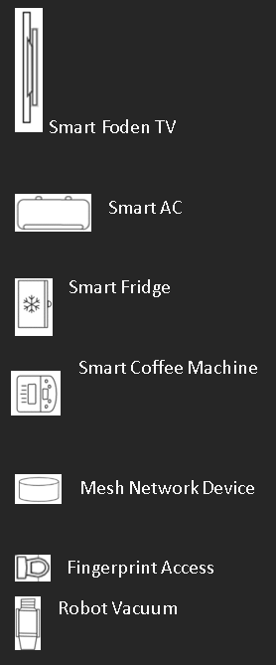

Cost of the technology for 8 by 2 bedroom
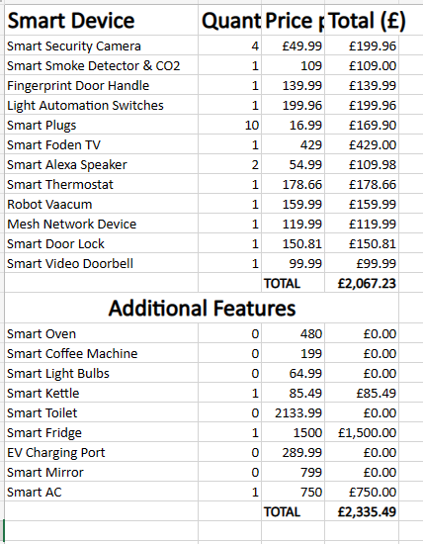
This is all the technology cost for the 8 by 2 affordable starter home.

6 by 4 family bedroom
This is a design for a family of 4/5 to which it contains suitable smart systems and features. On the following page
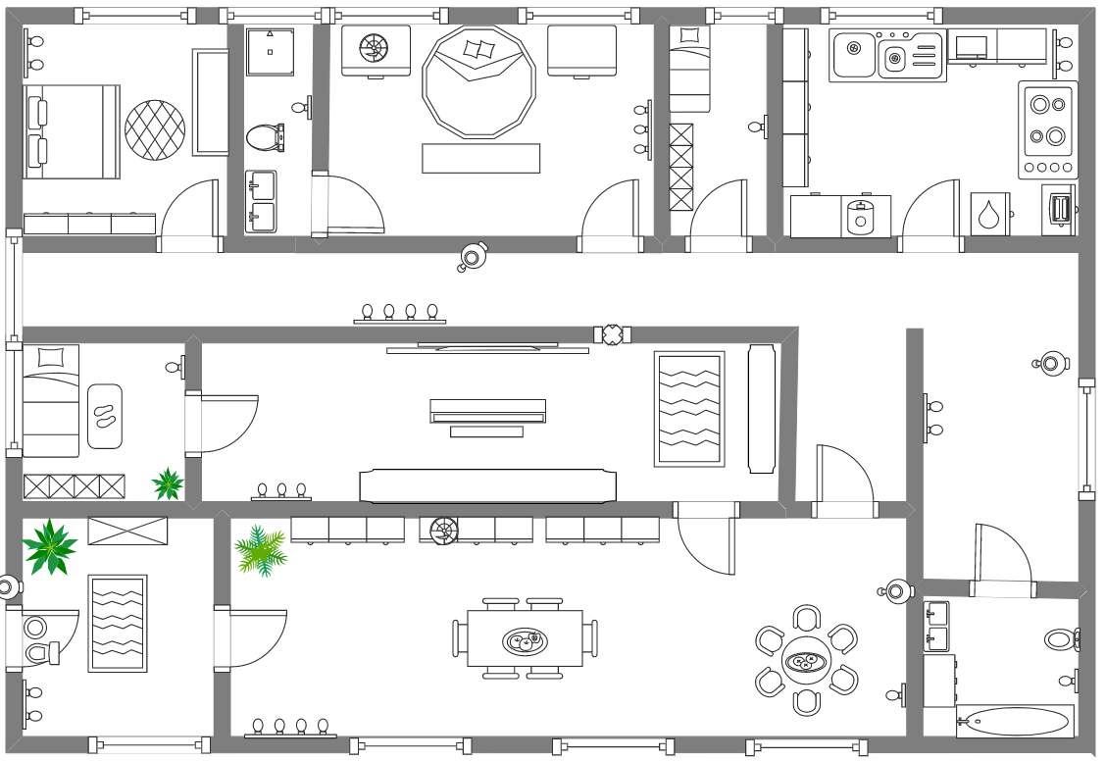
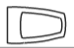




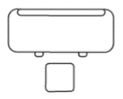
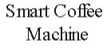


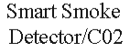
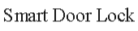
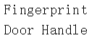
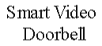
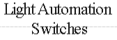



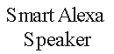
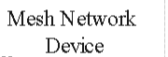
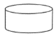
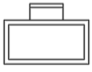

Smart Kettle
Smart Thermostat
EV Charging Point
EV Charging Point
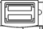
Smart

Edraw max (2023), all in one diagram available from wonder share at: https://www.edrawsoft.com/ad/edraw-max-soft-t.html ![date accessed 28th February 2023]
Cost of the technology for 6 by 4 bedroom
Down below are our costs for the smart devices and additional features, we have specified the total amount for the family homes.
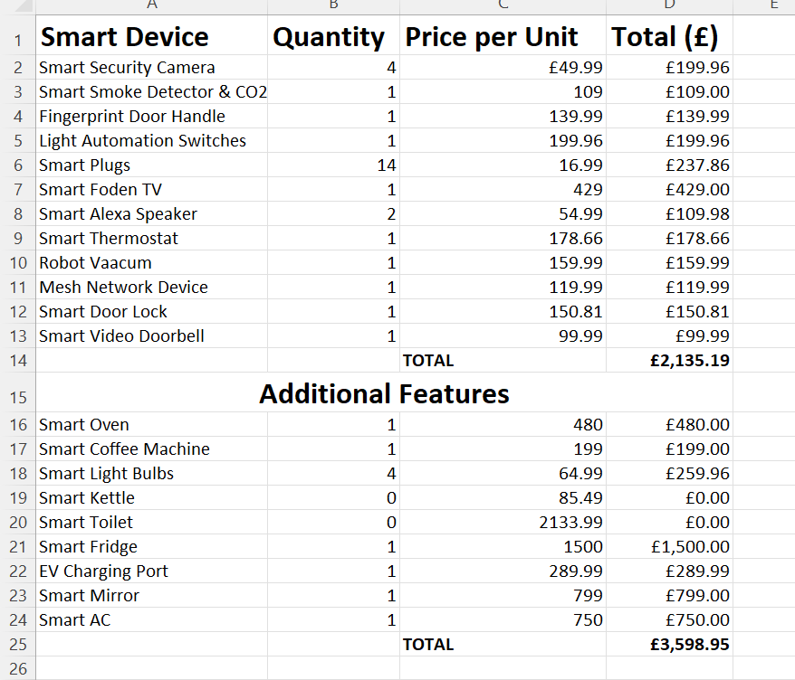
Care home Design





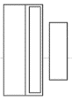


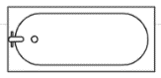
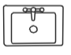

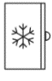
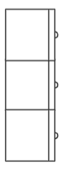
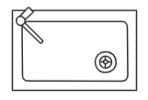
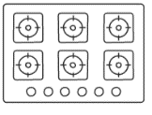


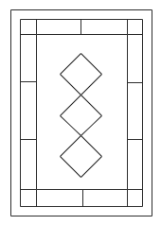



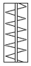
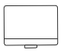

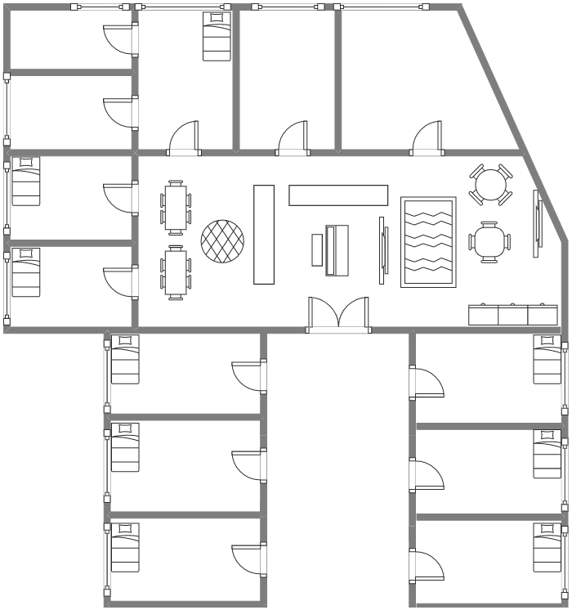
Smart Thermostat

Names of symbols


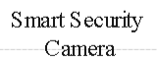








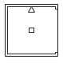
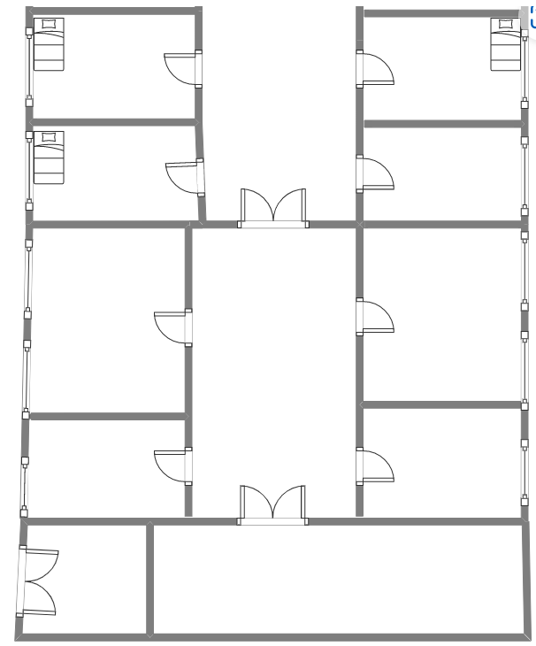

Names of symbols
Smoke Detector/Carbon Dioxide Detector.
Smart Plugs
Smart Light Bulbs
Smart Alexa Speakers
Smart Video Doorbell

Light Automation Switches

Smart Security Camera

Smart Foden TV
Smart AC

Smart Fridge

Smart Coffee Machine

Mesh Network Device
Fingerprint Access
Robot Vacuum

Smart Toilet

Smart Mirror

Smart Door Lock

Smart Thermostat

Technology cost of Care home elderly Complex

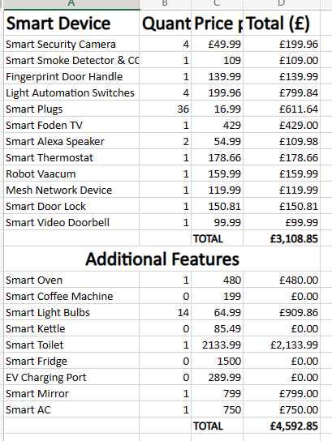

An outline of possible additional desirable features that might be available at additional cost to the purchasers of the homes.

Basic
Technology has been advancing rapidly recently and therefore it is important to be aware of the new technology that is available as this can improve the quality of life and reduce costs such as maintenance for example. I have listed below the smart technology that I would advise to implemented within all the different homes that we have been allocated (6 * 4-bedroom, 8 * 2 bedroom and sheltered home) with a brief description explaining my reasoning. For the prices of each individual product and the overall cost please refer to the data sheet provided.

- Smart indoor security camera – this is an important feature to have as it provides extra security for the residents as it will deter any thieves for example. It is very easy to use and will allow the residents to be able to see who is coming in and out of the house without physically having to be there.
- Smart Smoke and carbon monoxide alarm – this will allow residents to be alerted wherever there is a problem and therefore they can react quickly and get the help needed as early as possible.
- Fingerprint access – will allow residents a more secure way to enter their property and also keys can be lost which can be problematic for any of the residents as they will be unable to gain access to the property.
- LED lights – these are able to transform any room and each resident can select the colour that suits them, and this allows all the residents to feel more comfortable within their living space.
- Light automation – this is very important in terms of allowing the residents to change the brightness of the lights to whatever they find comfortable with and this can reduce the energy consumption which in doing so reduces the cost.
- Smart plugs – these will need to be available to work in conjunction with the other smart featured I have listed.
- Smart TV – it is economically worthwhile that you purchase one because they are not that expensive and they are widely available. This will in doing so also provide the residents with high quality of life as they will have access to plenty of entertainment on their TV.
- Smart speakers – this is one of the most important as this will voice commands to control many of the other smart features listed whilst also being affordable.
- Smart thermostat – in this current economy with the prices how they are it would be beneficial for everyone involved to have this implemented as you will have remote control of the heating and allows the residents to have better control of how they use the heating. Also, it will have information such as the estimated bill as well which will help residents manage their energy bill and reduces the disagreements.
- Robot vacuums – this will be a high initial investment compared to employing cleaners however it will save you money in the long run. It will clean up all day until it requires to be charged up which it will be able to do by itself. It is super quiet and will therefore not disturb the residents.
- Mesh network (Wi-Fi) – we believe this addition will provide faster speed, better coverage and more reliable connection. This will be an important feature for all the homes as when there are many devices the traditional Wi-fi cannot provide the same quality as a mesh network.
- Smart lock – this will allow the residents to be able to control who comes into the house without having to physically open the door as they can do it remotely. This is especially useful for example the elderly because if they have carers they do not have to get up and open the door they are able to do it from where they are.
- Smart video doorbell – is similar to the smart lock and in conjunction with that device this will work really well because you will be able to have two-way communication with the person at the door to see who is there and decide whether you want to let them in.

Additional

As I have previously stated technology is advancing rapidly which means new technology is available and the below technology is very useful I haven’t thought it to be a requirement and rather a luxury which I will explain in more detail for each one. This could be due to reasons regarding the cost or effectiveness for all the homes just to state a few examples. We would like to you to read the description and evaluate whether it is suitable for the budget or even if it is worthwhile for a specific home after reading the description as all the technology stated below, we would recommend if it is possible to implement.

Smart bulbs – we believe this technology would be suited for a family home because it would allow the families to reduce their energy bill because they are very efficient and can last 1000s of hours. As you can use a smartphone to control the light bulb it can be very useful as kids may not be able to reach the light switch or keep forgetting to turn of the light and this would allow the parent(s) to switch it off virtually. So, I would say that it would be beneficial to have for a family so long as you are able to justify it within the budget. We would like to also tell you that these bulbs are cost-effective in terms of looking at it from a long-term perspective.

For the sheltered home we feel that it would be a useful technology to have as the elderly won’t have to get up in the middle of the night for example in the dark as they can turn on the light from their smartphone virtually. However, they may also find it difficult to use and therefore will not actually use the technology frequently enough to suggest that it would be economically worthwhile and we would argue not however you may feel that it is and it is great piece of technology to have in place.

The affordable homes need to be kept to lower budget and the price of the bulbs plus the quantity required to cover the whole home would dent the budget quite significantly. This is why despite the usefulness we wouldn’t evaluate at it being a requirement.

Smart kettle – in a family home it may not be safe to have a kettle boiling water virtually as you are unable to monitor its surrounding. Therefor the children may be close to it and cause themselves harm. This is not the most expensive technology but its causes safety concerns and in addition to that it will not change the day-to-day life considerably either.

The sheltered home will find this useful to have within them as it would make the carers job easier as they will be able concentrate on the resident rather than the kettle. Therefore, we would suggest implementing it in the sheltered homes and the only reason we have not placed it within the basic technology section to be implemented is because the other 2 types of homes will not find it as useful.

The affordable homes will not require too much technology unless it is vital and the smart kettle does not fit that criteria and would just be adding extra costs for no reason. Also, as the residents will have to share 1 kettle it will likely cause quarrels which will lead to a bad living environment.

Smart toilets – if we were to implement this in a family home it would not be economically worthwhile especially if the family has young kids because they would probably be unable to use all the features as they will not know how to use it. Also, as they do not know how to use it then they will create other issues because they are pressing random buttons. The smart toilet is very expensive so unless you are completely sure that the residents in the family home will be able to use it for the price then it is a very good smart technology which can be regularly.

The sheltered home will benefit from this technology however you will need to consider the price as it is very expensive. We believe that it would improve day to day life of the residents and therefore would have placed it in the basic technology section is because it does not match the requirements for the other homes.

The affordable does not have the requirements that would suggest a smart toilet would be appropriate and that is why we would not suggest it however if the budget is available, we would say that is a very impressive technology and if possible should be looked as a viable option

Smart refrigerator – this technology is fairly new on the market but it already has so many benefits for the user. In a family home it would be very well suited because they will be able to make full use of the smart refrigerator. It will help families aware of the inventory of the items in the fridge and many other maintenance benefits for example if the fridge is having any problems they can be alerted. This will help them maintain the upkeep of the fridge. Despite all these benefits and others such as it being energy efficient it does have a high initial cost which if the budget allows then it would be a great addition.

The sheltered home would also benefit from the features because something like the inventory can allow others to be aware if the elderly resident requires anything as they currently have low stock, and they can buy it for them. This will improve the quality of life for the residents because they will not have to worry about always checking if they have sufficient resources in the fridge.

For the affordable it would be a great addition however you would have to argue that despite the benefits the initial cost would not be able to fit the requirements and you may require more than 1 in the home which will inevitably cause the costs to skyrocket. Also, we believe that you would not affect the daily life of the residents enough to constitute this additional cost as a standard fridge would be sufficient.

EV charging ports – with the government making it clear that they want to go towards electric cars it is important to consider what this could mean for future developments as the requirements for individuals will change. For a family they will more than likely have a car and if they have the ability to charge their car from their home then they will more than likely find not only the home suitable but also, they will be more likely to consider purchasing an electric car. This will in doing so impact the environment positively as there will be less emissions being omitted into the air. However, the problem now is that electric cars are expensive and especially for family who may require a bigger car and therefor you will need to analyse your potential residents and conclude as to whether they would be likely to make the change to electric cars.

In the sheltered accommodation it seems like there may not be enough demand for the EV charging ports and this is why we would advise you that it is not required especially when you consider most elderly people will not even have a car and even if they did then how likely would they be to change from what they have known all these years and change to electric and we would argue it is very unlikely. This additional cost may be of better use elsewhere in our opinion.

For the affordable home it may be useful, but it will depend more on the residents that will be staying as if they are unable to afford electric cars then it would not make any sense to implement this technology if nobody is going to utilise it. Also, you will have to consider the quantity you want to install because if you have only 1 and there are multiple electric cars it would be extremely difficult to navigate this issue and this will therefor cause issues between the residents.

Smart mirrors – this is very much a luxury item however and we believe it is very important because it will benefit the residents very much as it will help them improve their fitness. In the family home they would have more than enough space to be able to find space for this technology and it will benefit all the participants in the home because there are many different modes, they can select from also it can be used as a standard mirror if anyone is worried about the aesthetics. In a family home normally, it is difficult to have gym equipment’s such as a treadmill for example because of storage problems and safety concerns with kids around the house however this combats this issue. However, you will have to consider the price because it is very expensive and that is the reason as to why we could not have it part of the basic technology.

For the sheltered home this would also being a very useful addition because the residents will be able to have the chance to exercise with the help of instructors and also as we have previously discussed it will not take up any room because all it needs is to be hung on the wall. For the elderly sometimes, it is difficult to leave their home and this would help counter that and they can have the opportunity to stay as healthy as possible. The only issue is the price because it is very expensive but if you are able to overcome this issue, I do not see a reason why not to implement this technology in the sheltered home.

In our opinion this would be a great addition to the affordable home but the price makes it difficult to justify it to be implemented within home especially when you consider the if the residents were looking to stay healthy by exercising they will more than likely be able to afford a gym membership and that would be more than enough for them to achieve their fitness goals. If there was an unlimited budget then it would be a great addition however it is supposed to be an affordable home and you would be obliged to increase the price to cover yourself.

Smart window AC – as we have seen in recent times it has become extremely hot in the summertime and despite the homes being developed to withstand the cold weather we generally do not consider how we will combat the warm weather. In the family home it would be a great addition however we would argue that for most of the year the residents will not even require the technology so is possible to have reasons to justify the implementation, we would say it is not a requirement but would be a useful feature to have where possible.

In the sheltered home it would be the same issue as stated above but it would less justifiable as you would likely to require a higher quantity which would lead to it becoming very expensive and as we discussed above for most of the year you will not even require the technology.

The affordable home has a very similar discussion to the other homes that we understand that you may want to have AC because it has got hotter in the summer but for most days even in the summer you would easily be able to get through without AC and this is why we are not to convinced this is the right time to invest in this technology especially in the affordable where it would a high quantity to cover all the residents within the home.

In our opinion we would have the AC available however at the price it makes it unjustifiable to do so for the project you have however it is important to mention it is a very good technology and when required it will improve the standards of the homes greatly.
Smart coffee maker – there has been an increase in coffee consumption and a smart coffee machine provides high quality coffee and will also allow the customers to save their preferences this will help them save money as they will not require to always purchase one from a shop. Also, they can make it remotely and therefore it saves time and if someone is unable to make their own coffee it provides them with the opportunity of not missing out on drinking coffee.
For the family home it will be a useful feature because the parents in the home will be able to make their coffee remotely which will save them time especially when they have to make sure their kids get to school on time and if they also have work it they might not have time in the morning to go to the shops. Also, it will save them money daily because each coffee will be cheaper than buying it from the shops.
In the elderly home you would not expect them to be a high demand for this smart home technology because a lot of the elderly residents will prefer to drink tea over coffee. Despite their being tea pods available for certain machines it will not have the same taste and the elderly will normally only have a specific tea bag company that they only drink their tea from.
In the affordable home it would not be advisable because adding a coffee machine will result in the rent increasing and also as it would be a communal coffee machine it will require maintenance which will cause issues if none of the residents are willing to do this and will result in additional labour costs as you will require to have someone to do this as otherwise the coffee machine will get damaged.
Smart oven – it will help the residents when they are cooking as they can do it remotely whilst still being able to monitor their cooking and also, they will be able to gather information such as maintenance and cooking suggestions. Also, they have a function to clean the oven which I believe is vital because some people may be unable to do this and/or unwilling to do this which can result in having to change the oven more frequently which will be additional maintenance costs that you will have to incur.
In the family home it will be useful as a lot of time the parents are both working and this will help them save time in preparing the food and also it will automatically clean itself allowing for better maintenance and longer lasting oven. Therefor the initial investment will be in the long term worthwhile.
For the elderly home it will also be very important as it will allow the carers and staff of the care homes to take care of the residents better by provide a better service. This will also allow the residents of the care home to have the chance to cook where they would not have otherwise been able to do so because now they can do it remotely as some of the elderly are not physically able to monitor the oven.
In the affordable home you would not require it as a necessity it would be more of a luxury and therefor it would not be appealing for the residents especially if this leads to an increase in the rent that you will be demanding and you do not want to reduce the demand for your homes as you may not be able to find residents to fill all of the accommodation.
References:
- Statista (2023). Household penetration of smart TV sets in the United Kingdom (UK) from 2014 to 2022. Available from Statista at:https://www.statista.com/statistics/654074/smart-tv-penetration-in-uk-households/ | [Accessed: 04/03/2023]
- Fourchu, C., Serrato, J., Lizotte, D., Mann, R., Taylor, G. and Husni, S. (2022) [1]. Developing a Smart Home Technology Innovation for People with Physical and Mental Health Problems: Considerations and Recommendations. Available from National Library of Medicine at:
https://www.ncbi.nlm.nih.gov/pmc/articles/PMC9107043/ | [Accessed: 04/03/2023]
- Robles, R. and Kim, T.-H. (2010). A Review on Security in Smart Home Development. Available from International Journal of Advanced Science and Technology at:
https://citeseerx.ist.psu.edu/document?repid=rep1&type=pdf&doi=f07fd4d666c9fe05e49501884054f6041d554ad5 | [Accessed: 05/03/2023]
- Adam Hayes (2022). Smart Home: Definition, How They Work, Pros and Cons. Available from Investopedia at: https://www.investopedia.com/terms/s/smart-home.asp | [Accessed 10/03/2023]
Conclusion:
We can conclude that smart homes technology is highly worth considering and implementing not only in our given project, but also into homes in general. This document has discussed how smart devices can improve the quality of life of families, care homes residents and individuals who wish to live inside shared accommodations. We have worked towards making these proposed smart home designs as affordable as possible for all three types of residents while also ensuring that the minimum requirements in terms of smart devices have been met to feel the impact that these highly capable technologies have on our way of living.

